Touchstone Task 3 – Final Project

A. Introduction
This project is a multi-page website created for ABC Fitness Studio. The purpose of the website is to promote fitness services, provide product offerings, and allow users to interact with features such as subscribing, adding items to a shopping cart, and submitting custom orders.

The website includes four pages: Home, Gallery, About Us, and Community. Each page was designed to provide a specific function, including introducing the business, displaying services and products, collecting user information, and highlighting community engagement.

Website Link:
https://basic-webpage-creator--franciscafalais.replit.app/
B. Design and Wireframes
The website design was based on a clean and modern fitness theme. The goal was to create a layout that is easy to navigate while also visually appealing.

The color palette includes soft background tones with darker text colors to maintain readability. Simple and professional fonts such as Arial were used to keep the content clear and accessible.

Each page follows a consistent layout:
- Header with logo and navigation
- Main content area
- Footer with additional information

C. Website Structure
Home Page:
Welcome message, promotions, featured services, subscription section.

Gallery Page:
Fitness services and product listings, Add to Cart buttons, cart features.

About Us Page:
Business description, business hours, contact and custom order form.

Community Page:
Testimonials, community involvement, events.

D. CSS Styling
CSS was used to create a consistent and visually appealing design across all pages. Styling includes consistent colors, spacing, layout organization, and styled buttons.

E. Accessibility
Accessibility features include clear headings, readable fonts, labeled form inputs, alt text for images, and consistent navigation.

F. Responsive Web Design
The website adapts to different screen sizes using flexible layouts and responsive design techniques.

G. JavaScript Features
JavaScript adds interactivity including alerts, cart functionality, and form submission confirmation.

H. Web Storage Functionality
sessionStorage is used to store items added to the shopping cart. localStorage is used to store customer and custom order information submitted through the contact form.

K. Screenshots of Website Features

Figure 1: Home Page Layout
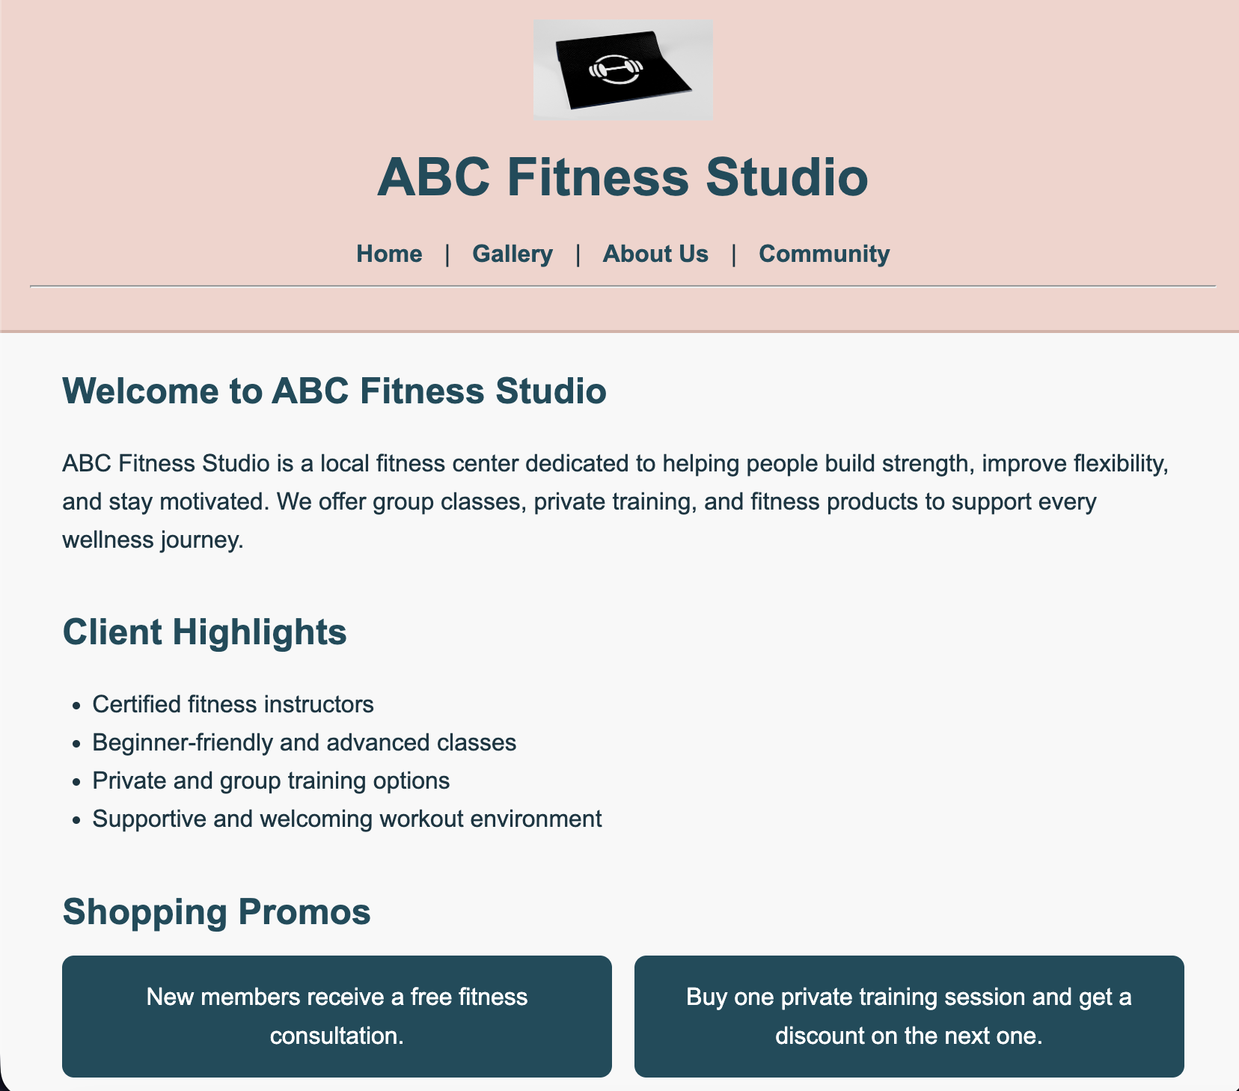

Figure 2: Gallery Page with Products
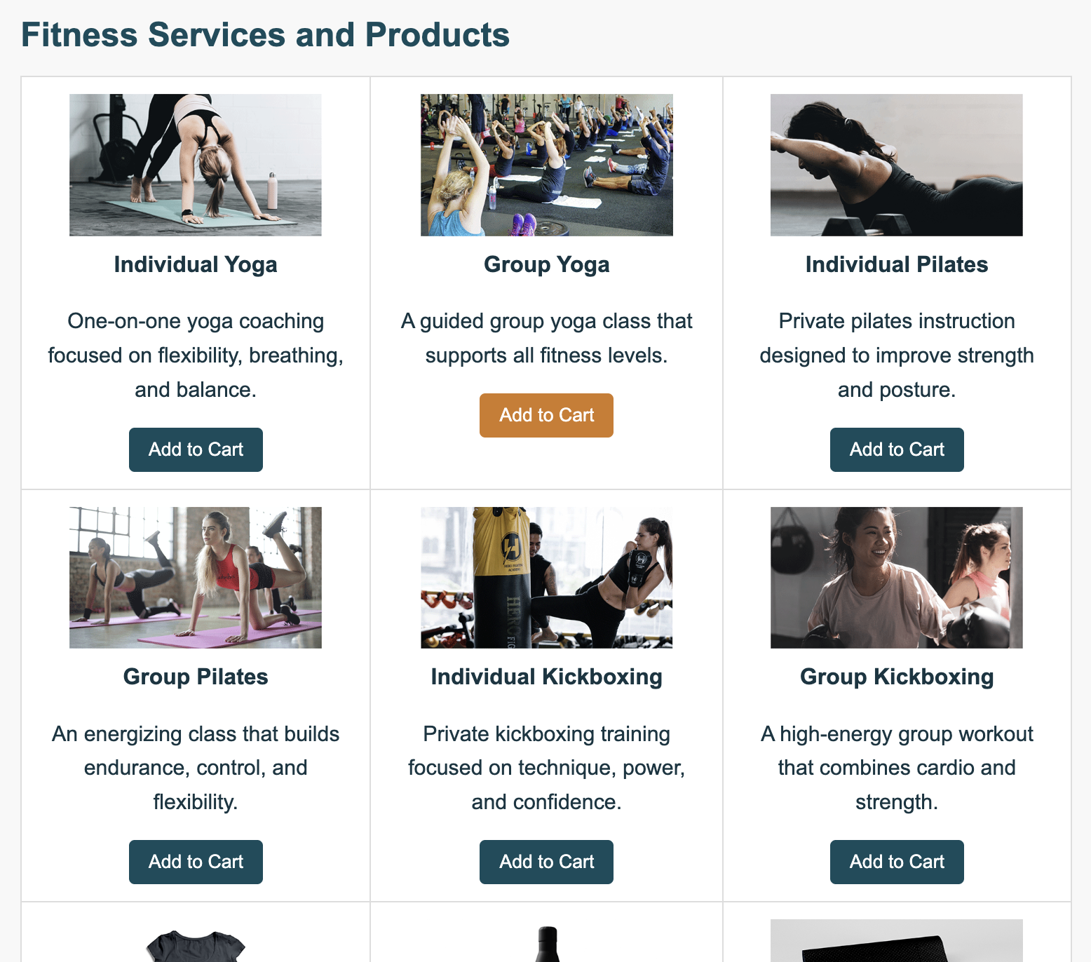

Figure 3: Shopping Cart with Items (sessionStorage)
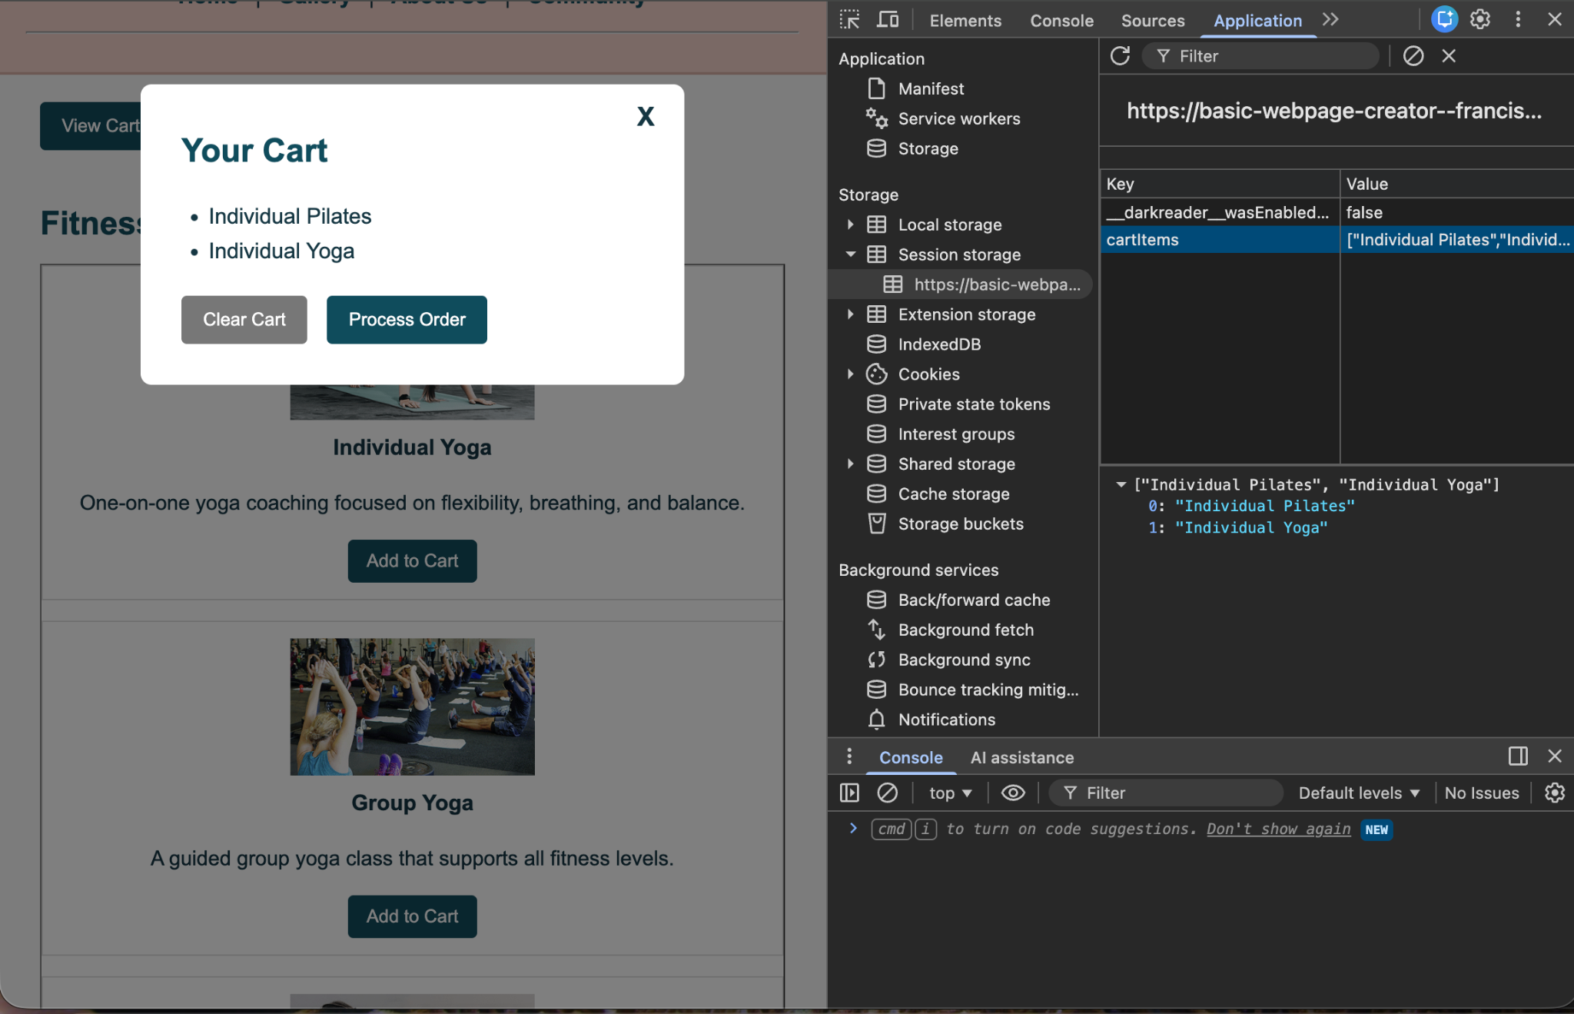

Figure 4: Shopping Cart Empty After Clearing (sessionStorage cleared)
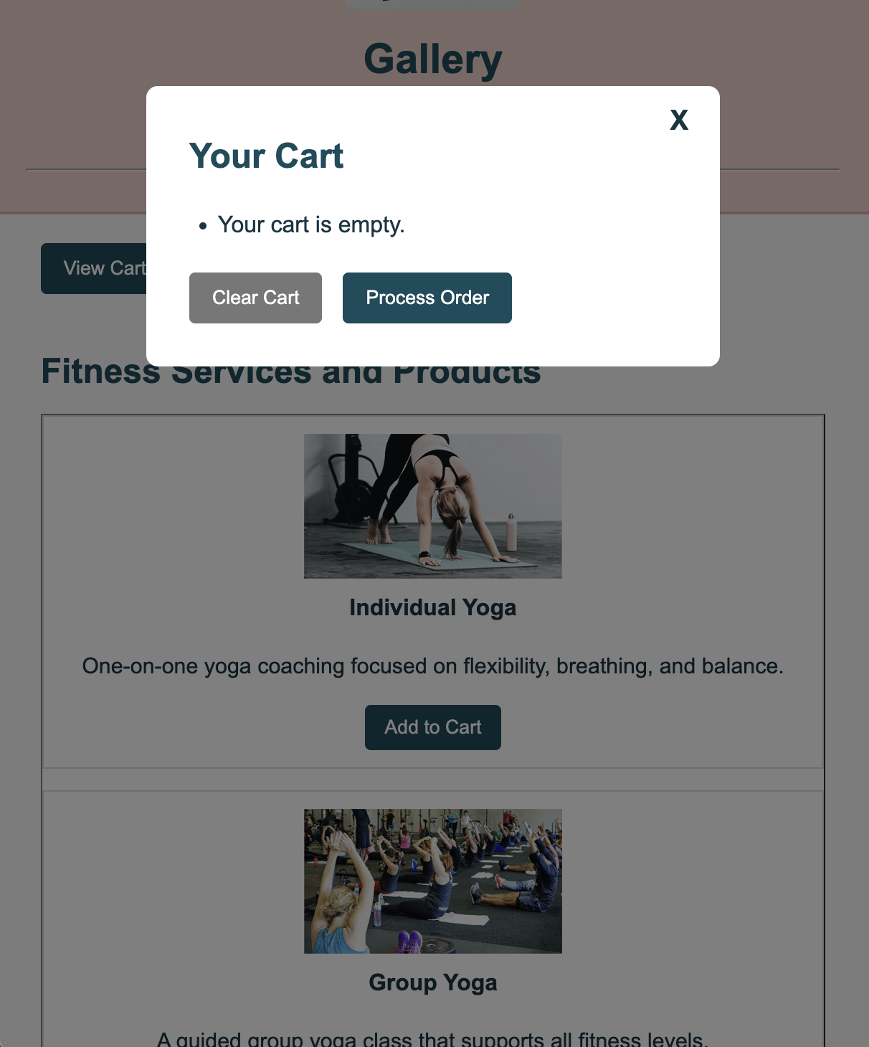

Figure 5: Browser SessionStorage (Before Clearing Cart)
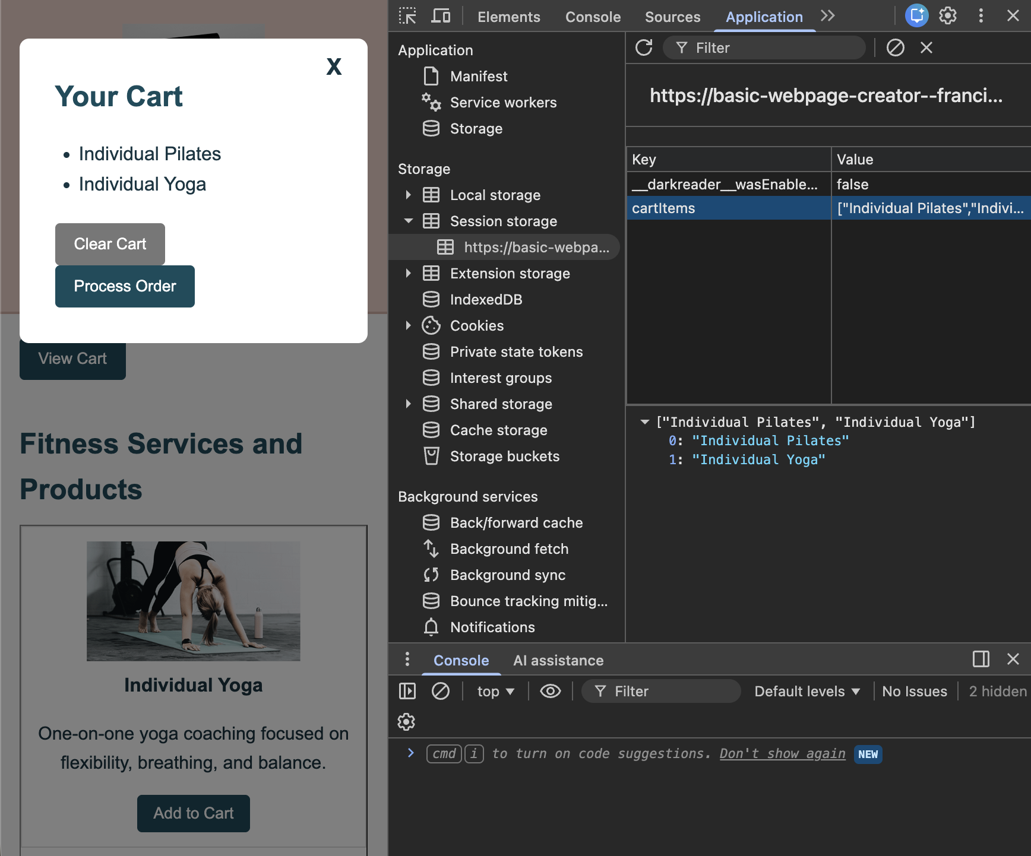

Figure 6: LocalStorage Data (Custom Order Form)
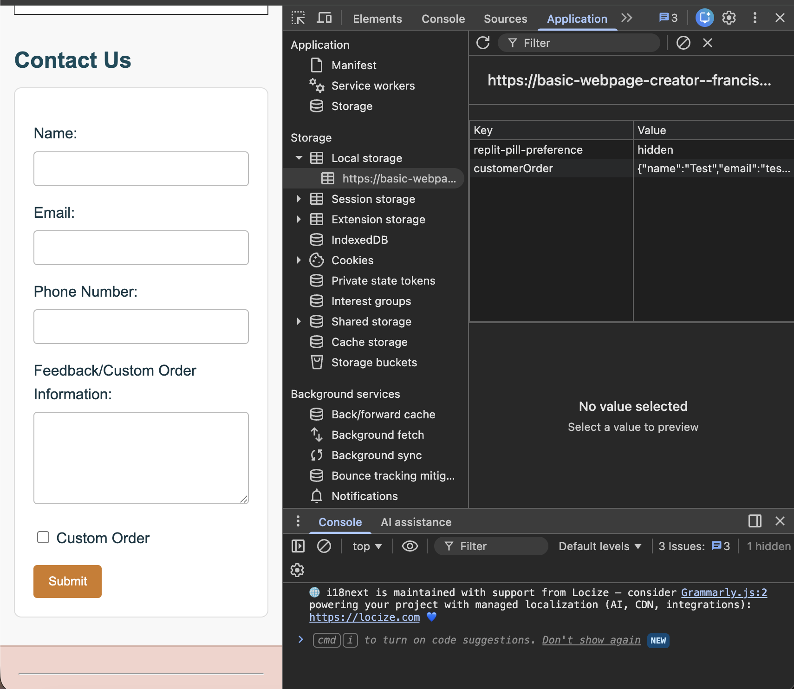

Conclusion
The project successfully demonstrates the integration of HTML, CSS, JavaScript, and web storage. The website allows users to interact with features such as adding items to a cart and submitting custom orders while storing data effectively.

